# INTRODUCTION

# The event management system is employed to manage all the activity associated with an occurrence. In any event, several service suppliers’ work at the same time and it's terribly arduous to manage these suppliers. it's conjointly necessary for event organizer that he has all the contacts details of those service suppliers in order that he will contact them any time to arrange an occurrence at a given time. To manage of these activities we've developed this computer code. To need success within the event management system, the scholar ought to have robust network contacts of the service supplier. These contacts area unit essential suppliers of specific services UN agency is mobilized quickly to participate in any given event, during this system student can participate in an occurrence through the web registration. Student can get all details concerning events online once the login. HOD can update all info on the event on the department portal and also the student can simply get all the small print. Once the event initial spherical is completed the qualified and non-qualified students list are on the market on Admin module and HOD can continue the more procedure. Once completion of the event, all participated students, in addition as winner students, can get their certificate on their Gmail account. The planned system rising the potency by Automatic and implementing event collaboration, monitoring and management system. Offer reliable and easy event management system. This technique helps the event management company to manage their work on-line and that they also can retrieve a report of the last event they need completed.

# Problem Definition & Design Thinking

* 1. Empathy Map
  2. 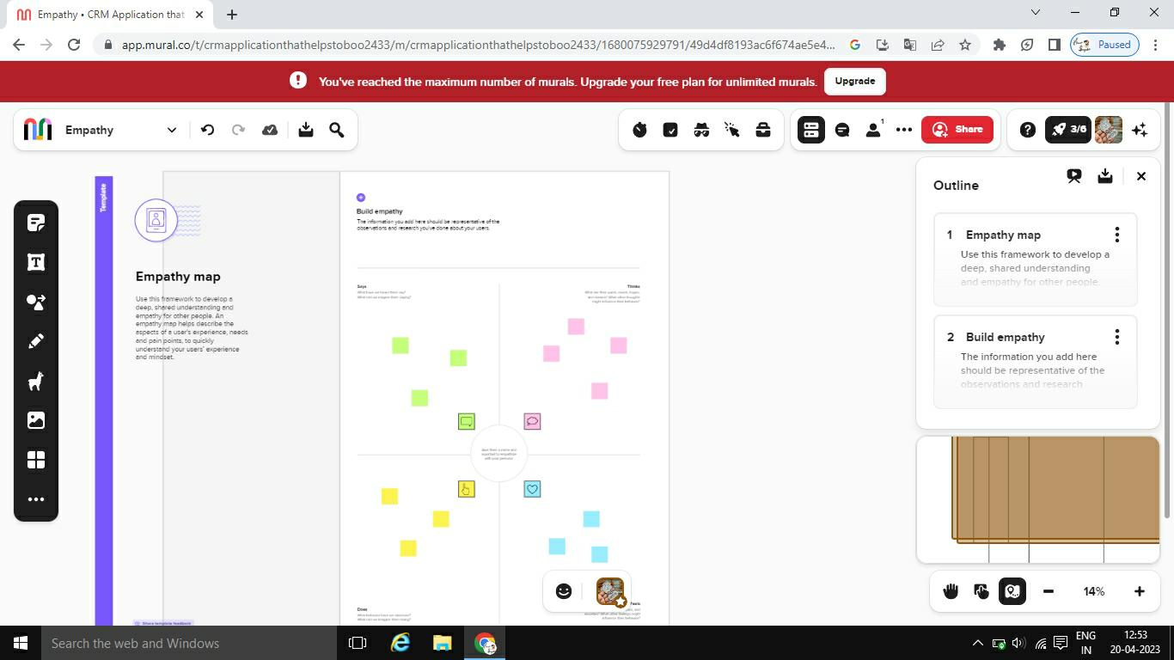
  3. Ideation & Brainstorming Map
  4. 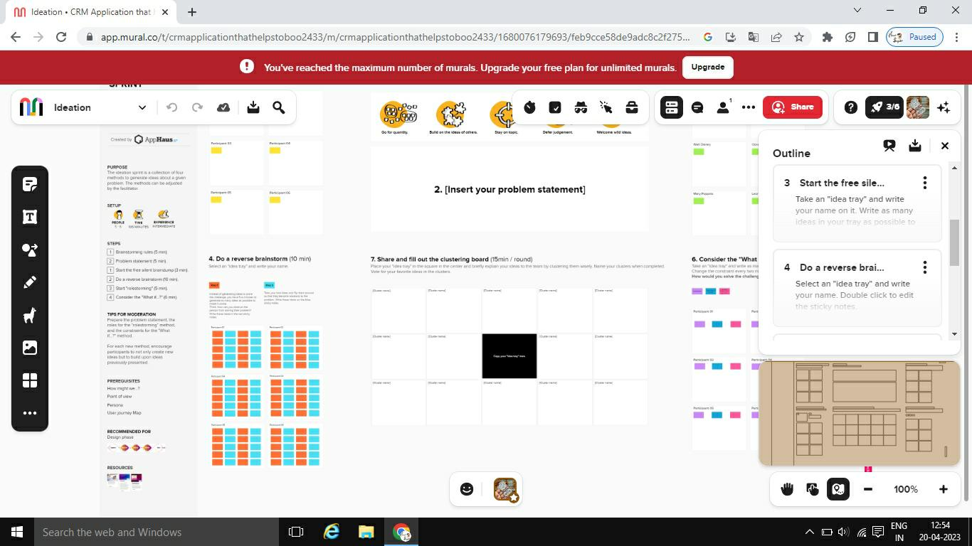

# RESULT

* 1. Data Model:

|  |  |
| --- | --- |
| **Object name** | **Fields in the Object** |
| Object 1 | |  |  | | --- | --- | | Field label | Data type | | Passport | Custom Field Definition | |
| Object 2 | |  |  | | --- | --- | | Field label | Data type | | Location | Custom Field Definition | |
| Object 3 | |  |  | | --- | --- | | Field label | Data type | | Visa-slot | Custom Field Definition | |
| Object 4 | |  |  | | --- | --- | | Field label | Data type | | Passport number | Custom Field Definition | |

# Activity & Screensho

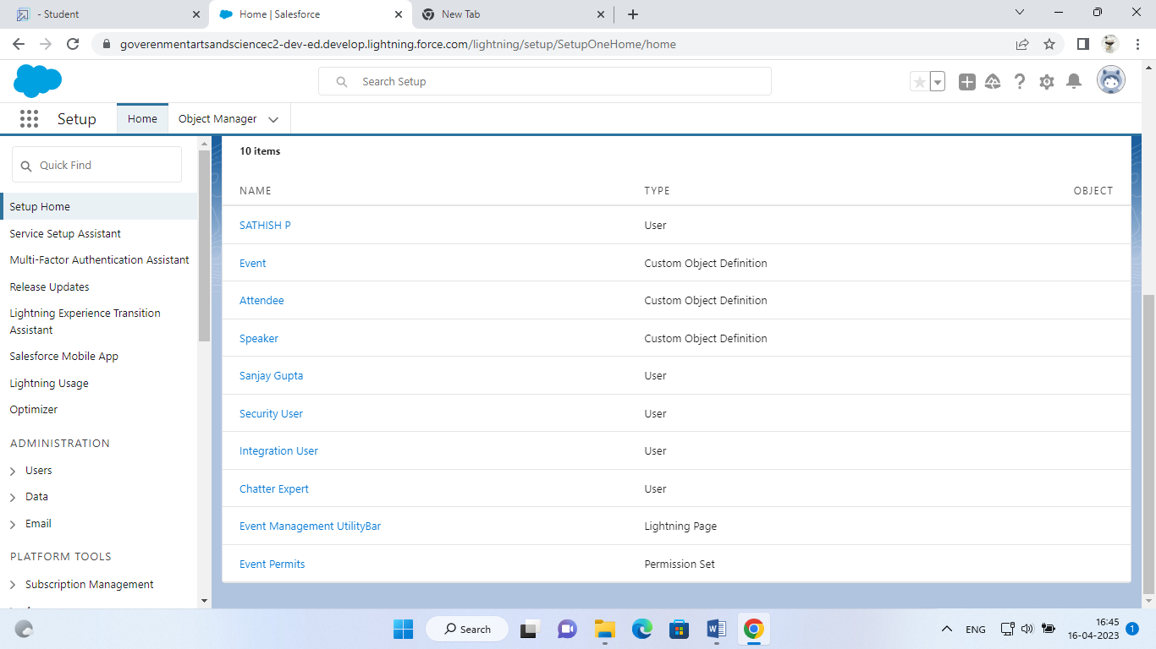

# Trailhead Profile Public URL

**Team Lead-https://trailblazer.me/id/vasanthakumarr71**

**Team Member 1 – https://trailblazer.me/id/vasanthakumarr71**

**Team Member 2-https://trailblazer.me/id/vasanthakumarr71**

**Team Member 3 - https://trailblazer.me/id/vasanthakumarr71**

1. **ADVANTAGES & DISADVANTAGE**

**ADVANTAGES OF PROPOSED SYSTEM**

• Registration for an event can be within the time

• Complete work on time

• Management of workflow can be done easily

• Increase the accessibility

**DISADVANTAGES OF THE EXISTING SYSTEM**

• Difficult to handle work manually.

• Time consuming process.

• More human power required.

APPLICATIONS

# 

### **Event Ticketing Apps**

These types of apps generate and distribute your event tickets. It enables you to sell your tickets online and collect payments for them. Some apps with advanced features can support custom selling and manage event attendance.

### **Event Scheduler Apps**

These types of apps help your guests check in on your event programs. The participants can even reschedule or cancel their bookings.

### **Survey Apps**

These apps make it easier for you to get feedback from your event participants through online polls and survey forms. The results will help you analyze the success of your events.

### **Web Conferencing Apps**

These types of apps can broadcast your event to a broader audience through live streaming.

### **End-to-end Event Management Apps**

These types of apps empower you with solutions that support almost all of your pre-event preparation needs from ticketing, budgeting, event scheduling, marketing, and feedback collection.

# CONCLUSION

# Event Management System (EMS) could be a terribly effective application which might be accustomed an excellent extent. EMS have several benefits over the normal system. A number of these blessings are centralized knowledge, up-todate standing coverage, E-mail notification, simple use, backups etc. the employment of this application reduces the additional time and efforts needed to manage and monitor the events in schools